**LAB1 Report**

## 組員與分工

* Date: 11/17
* TeamID: 7
* Member: 0716311 李軒 0716011 郭仲恩 0616078 唐宇謙 0710176 張政友

## 實驗目的

The goal is to firstly establish the environment for later megawin MPC82G516 programming, and firstly operate simple LED module by MPC82G516 module by simple 51 code

## 實驗器材

* + Megawin MPC82G516 device
  + Several jumping wires
  + LED module(74ls244 module)
  + Keil5uVision

### HARDWARE

1. MPC82G516 8051 device->by 51code, control the output of ports of device(P0:0000_0000[8bits output]) 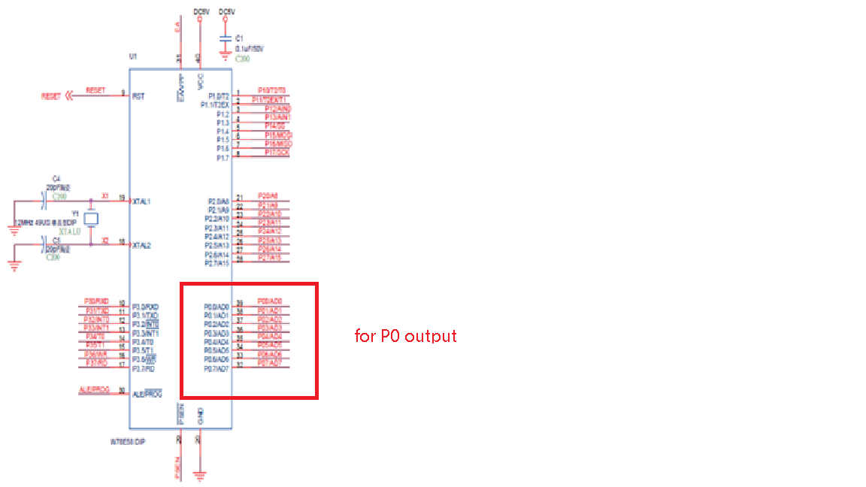every pin is an output as a bit(0/1),and can be moderate by (Mov Px,A), except each port , the other Vlt pins and GND pins are set up proper originally.

1. Jumping wires->send the output of device port to LED module

(pin by pin) 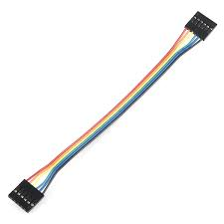

1. LED(74ls244 module)->by input, control the the on/off of the LED, 8bits:1for off, 0for on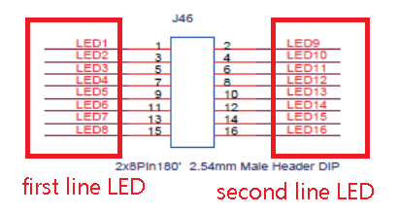

Software  
The device in Keil5uVision is Megawin MPC82G516, which is not in the original database->go to Megawin website download the database

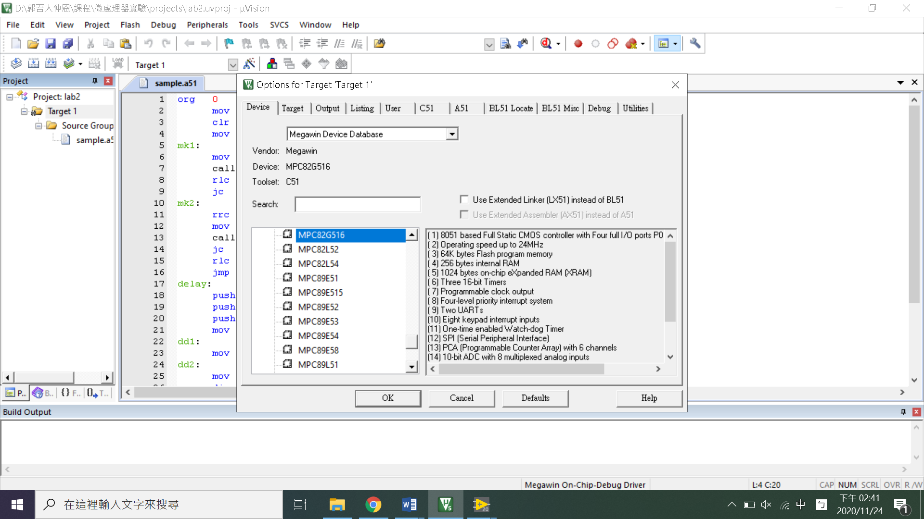

## ([http://www.megawin.com.tw/zh-tw/support/index/1/23/1/95)](http://www.megawin.com.tw/zh-tw/support/index/1/23/1/95)#)

## The downloaded program can inject the needed database into keil program.

## 實驗設計

### 架構

We use P0, 0-7 as output to control the 8LED, 0 for the light-on, 1 for the light-off

Begin as #0FF(1111_1111) continuously rotate left->0 runs right to left and back to #0FF ,and rotate right->0 runs left to right [light runs right to left and back to right]

And between every rotation ,the device delay for a while for the user to see difference.

### 程式碼

* Register meaning

| **container** | **meaning** |
| --- | --- |
| A | To store the byte sending to output port |
| P0 | Output port |
| R5 | Num for delay |
| R6 | Num for delay |
| R7 | Num for delay |
| c | Carry represent light-on |

* Code structure

org 0

mov sp, #50H

clr c

mov A, #0ffH

mk1: ;; rotate left

mov p0, A ;; output by port

call delay ;; delay for user

rlc a ;; rotate left

jc mk1

mk2: ;; rotate right

rrc a ;; rotate right

mov p0, A ;; output by port

call delay ;; delay for user

jc mk2

rlc A

jmp mk1 ; ==BB== ;; go back to mk1

;; Delay function

delay: ;; delay by execute r5*r6*r7 times of djnz

push 5 ; push R5???

push 6

push 7

mov r5, #10 ; ==AA==

dd1:

mov r6, #200

dd2:

mov r7, #250

djnz r7, $ ;

djnz r6, dd2

djnz r5, dd1

pop 7

pop 6

pop 5

ret

;; Delay function END

end

* Delay function

When enter the delay function, it makes r5 = 10, and enter dd1. Dd1 makes r6 200, and enter dd2. Dd2 will do djnz for 250 times, and go back to dd1 (if r6 != 0)….

->dd2 do 250 times djnz ,and dd1 do 200 times dd2 ,and delay do 10 times dd1->at least 250*200*10 = 500000 times of djnz

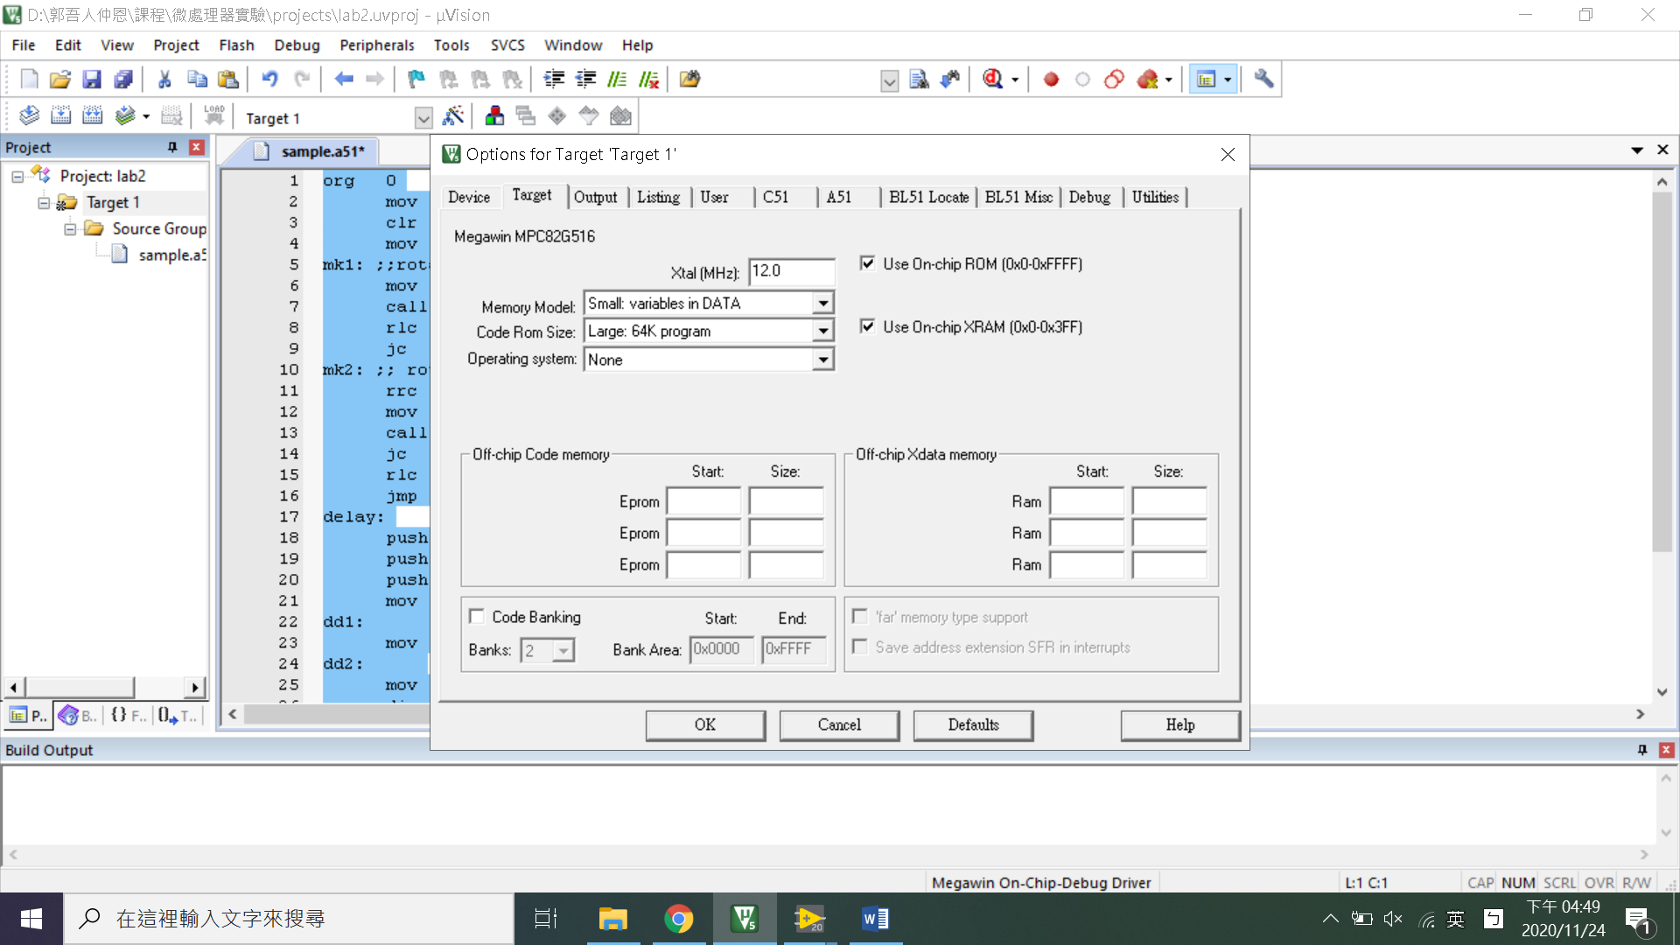

Should be 12M instruction per second

->500000 instructions take 1/24 second to execute

[pause 1/24 second~~~]

### 接線架構

**Difficulties encountered and resolutions**

* Difficulties:
  1. At the very beginning, I cant find out where is the megawin device in Keil 51uVision->have to download online for extra database
  2. At the beginning, our LED is not glowing-> power wire is dead -> no power for the LED.
* Questions:
  1. How to output the acquired output :

Mov P0, A->P0 output the byte as 8pins

* 1. How to let the module delay:

make the device operate millions non-functional operations , then go back to the normal code-> djnz r5,$ [continue r5--, until r5==0]-> combine several djnz can execute non-functional code for x1*x2*x3 times

* 1. How the LED module act:

there are 8 pins as input, each pin indicate 1 LED(0 for on, 1 for off)